EFFECT OF SYZYGIUM AROMATICUM (CLOVE) HYDROALCOHOLIC EXTRACT ON MYOMETRIAL CONTRACTILITY IN MICE.

BY
OPHORI EMUAGHOGHO HALE
PHA1908576

A DISSERTATION SUBMITTED IN PARTIAL FULFILLMENT OF THE REQUIREMENT FOR THE AWARD OF THE DOCTOR OF PHARMACY (PHARM.D) DEGREE OF THE UNIVERSITY OF BENIN, NIGERIA
DEPARTMENT OF PHARMACOLOGY AND TOXICOLOGY
FACULTY OF PHARMACY
UNIVERSITY OF BENIN
BENIN CITY, NIGERIA
NOVEMBER 2025

CERTIFICATION
This is to certify that this research work titled “Effect of Syzygium aromaticum (Clove) Hydroalcoholic Extract on Myometrial Contractility in Mice.” was carried out by master Ophori Emuaghogho Hale, with the matriculation number PHA1908576 in the Department of Pharmacology and Toxicology, Faculty of pharmacy, University of Benin City, Nigeria.
………………………………….. ……………………………
DR.(MRS) ADAEZE UCHENDU DATE
Supervisor

………………………………… …………………………..
DR.(MRS) ADAEZE UCHENDU DATE
Head of Department

CERTIFICATE OF NO PLAGIARISM
This is to certify that this research paper submitted by master Ophori Emuaghogho Hale titled “Effect of Syzygium aromaticum (Clove) Hydroalcoholic Extract on Myometrial Contractility in Mice.” has successfully passed the plagiarism detection test and does not violate any copyright regulations. This paper is entirely original and free from any plagiarised content

…………………………………… …………………………….
OPHORI EMUAGHOGHO HALE Date
Student

………………………………… ……………………………….
DR (MRS.) ADAEZE UCHENDU Date
Supervisor

…………………………. …..………………………….
DR (MRS.) ADAEZE UCHENDU Date
Head of Department

DEDICATION
This work is dedicated to God Almighty, whose boundless grace, wisdom, and guidance have helped me in every step of this journey. This project is also dedicated to my late mother

ACKNOWLEDGEMENT
I would like to begin by expressing my heartfelt gratitude to God for his help throughout my academic journey.
I am also grateful to my exceptional project supervisor, Dr. (Mrs.) A. Uchendu, whose
patience, kindness, vast knowledge, and unwavering academic support were instrumental in the
success of this work. A special acknowledgment goes to Mr. Phillip and Mr. Ibe for their invaluable assistance and support which was crucial throughout my research.
A special acknowledgment goes to my biological parents, Hon. Henry Ophori and late (Mrs.) Beatrice Ophori. I also want to appreciate my siblings Hearty, Rejoice, Excel, Azriel and Onome for their love and massive support. I also want to specially acknowledge my big parents, Chief and Chief (Mrs.) Pius Odioko Ovbije for thier love, encouragement and financial support. I would also like to express my deep gratitude to my grandmother, Mrs. Elizabeth Omih for her constant prayers and my aunties Mrs. Bateren Theresa, Mrs. Onakpoma Mercy, Mrs Efe Ugbiyoma and Mrs. Caroline Olomu for their constant support. I also want to specially appreciate the family of Dr. and Mrs. Enoch Omih for their constant support and accommodation as my immediate nuclear family in Benin. I also appreciate my uncles, Professor Eddy Ophori and Mr. Efe Ophori for their help and assistance.
I want to acknowledge my project partners Eghosa, Annabella and Miracle for their unwavering support throughout this project work. I also want to specially appreciate my friends Courage, Fego, Goodluck, Charles, Great-Nelson, Michelle, Edesiri, Iredia, Sandra, Ebiama Rejoice, Miebi and Testimony for their support throughout my academic journey. Finally, I want to appreciate Nwaenyi Christabel Amarachi for her emotional support throughout this project work

TABLE OF CONTENTS
TITLE PAGE i
CERTIFICATION ii
CERTIFICATE OF NO PLAGIARISIM iii
DEDICATION iv
ACKNOWLEDGEMENT v
LIST OF ABBREVIATIONS v
TABLE OF CONTENTS vi
LIST OF FIGURES ix
LIST OF ABBREVIATIONS x
ABSTRACT xiv
CHAPTER ONE: INTRODUCTION AND LITERATURE REVIEW 1
1.1 Human Female Reproductive System 1
1.2 The Human Uterus 4
1.3 The Ovarian and Endometrial Cycle 5
1.4 The Mouse Uterus 6
1.5 The Female Mice Reproductive Cycle 7
1.6 Uterine Myometrial Contractility 8
1.6.1 Cellular Basis of Myometrial Contraction 8
1.6.2 Electrical and Mechanical Coordination 9
1.6.3 Pathophysiology of Uterine contractions 9
1.7 Drugs Implicated in Uterine Contractility 11
1.7.1 Tocolytics 11
1.7.2 Oxytocics 16
1.8 Herbal Medicines 17
1.9 Taxonomic Classification and Overview of Syzygium Aromaticum 20
1.9.1 Plant Description 20
1.9.2Uses of Syzygium Aromaticum 21
1.9.3 Phytochemistry of Syzygium Aromaticum 22
1.10 Rationale of the Study 23
1.11 Research Questions 23
1.12 Study Hypothesis 24
1.13 Aim and Objectives of the Study 24

CHAPTER TWO: MATERIALS AND METHODS 26
2.1 Materials 26
2.1.1 Chemicals and Reagents 26
2.1.2 Collection and Extraction of Plant Material 27
2.1.3 Animals 28
2.1.4 Uterine Tissue Preparation 28
2.2 Methods 29
2.2.1 Effect of S. aromaticum Extract on Spontaneous Uterine Contraction 29
2.2.2 Effect of S. aromaticum Extract on Oxytocin-Induced Uterine Contraction 29
2.2.3 Effect of S. aromaticum Extract on High KCl-Induced Uterine Contraction 30
2.3 Data Analysis 30

CHAPTER THREE: RESULTS 30
3.1 Effect of S. aromaticum Extract on Spontaneous Uterine Contraction 30
3.2 Effect of S. aromaticum Extract on Oxytocin-Induced Uterine Contraction 30
3.3 Effect of S. aromaticum Extract on High KCl-Induced Uterine Contraction 35

CHAPTER FOUR: DISCUSSION 38

CHAPTER FIVE: CONCLUSION 47
5.1 Recommendations 47

REFERENCES 48

LIST OF FIGURES
3.1: Effect of the hydroalcoholic extract of S. aromaticum (SAE) on spontaneous uterine contractility of non-pregnant animals 31
3.2: Concentration -response curve showing the effect of SAE on amplitude, frequency and the area under the curve of spontaneous uterine contraction 32
3.3: Effect of the hydroalcoholic extract of S. aromaticum (SAE) on oxytocin-induced uterine contractions in non-pregnant animals. 33
3.4: Effect of the SAE on amplitude, and frequency of oxytocin-induced uterine contractions in non-pregnant mouse uterus. 34
3.5: Effect of the hydroalcoholic extract off S. aromaticum (SAE) on high KCl-induced uterine contractions in non-pregnant animals. 36
3.6: Effect of the ethanol extract of S. aromaticum (SAE) on high KCl-induced uterine contractions in non-pregnant animals. 37

.

LIST OF ABBREVIATIONS
ABBREVIATION | MEANING
ALB | Albumin
ALP | Alkaline Phosphatase
ALT | Alanine Aminotransferase
AST | Aspartate Aminotransferase
AUC | Area Under the Curve
Β | Beta-2 Adrenergic Receptor
BUN | Blood Urea Nitrogen
CA | Calcium Antagonist
CaCl₂ | Calcium Chloride
cAMP | Cyclic Adenosine Monophosphate
CCBs | Calcium Channel Blockers
°C | Degrees Celsius
DAG | Diacylglycerol
DNA | Deoxyribonucleic Acid
EC₅₀ | Half Maximal Effective Concentration
EDTA | Ethylenediaminetetraacetic Acid
E₂ | Estradiol
FSH | Follicle-Stimulating Hormone
G | Gram
GFR | Glomerular Filtration Rate
GnRH | Gonadotropin-Releasing Hormone
HCO₃⁻ | Bicarbonate Ion
hCG | Human Chorionic Gonadotropin
HDL | High-Density Lipoprotein
HPV | Human Papillomavirus
IP₃ | Inositol Triphosphate
K⁺ | Potassium Ion
KCl | Potassium Chloride
LDH | Lactate Dehydrogenase
LDL | Low-Density Lipoprotein
LH | Luteinizing Hormone
mL | Milliliter
mg/mL | Milligrams per Milliliter
mM/L | Millimoles per Liter
µL | Microliter
µM | Micromolar
Na⁺ | Sodium Ion
NaCl | Sodium Chloride
NaHCO₃ | Sodium Bicarbonate
n | Number of Samples or Animals
nM | Nanomolar
OT | Oxytocin
PBB | Plant Biology and Biotechnology
PCOS | Polycystic Ovary Syndrome
PID | Pelvic Inflammatory Disease
PLC | Phospholipase C
PSS | Physiological Saline Solution
RBC | Red Blood Cell
RNA | Ribonucleic Acid
SAE | Syzygium aromaticum Extract
SEM | Standard Error of Mean
TCM | Traditional Chinese Medicine
TChol | Total Cholesterol
TG | Triglycerides
UPS | Uninterruptible Power Supply
Ur | Urea
WBC | White Blood Cell
WHO | World Health Organization

ABSTRACT
Syzygium aromaticum (clove) is a widely used aromatic spice and traditional herbal remedy valued for its diverse pharmacological properties, including analgesic, anti-inflammatory, antioxidant, and antimicrobial effects. Unpublished studies have shown that S. aromaticum exhibits an inhibitory effect on myometrial contraction of non-pregnant mice. Clove represents a promising phytotherapeutic candidate for conditions associated with uterine hyperactivity, such as dysmenorrhea, preterm labour, and threatened abortion, thus warranting deeper exploration into its mechanism of action.
This study aimed to evaluate the effect of clove extract on the contractility of myometrium strips isolated from non-pregnant mice. A hydro-ethanolic extract was obtained from the powdered leaf material using a Soxhlet apparatus. Twenty-five non-pregnant albino mice were used, and those in the estrous phase (identified by vaginal smears) were humanely sacrificed Uterine strips from non-pregnant mice (20–28 g) were vertically suspended in a 10 mL organ bath. The effects of various concentrations of clove extract (0.006–0.2 mg/mL) were cumulatively examined on spontaneous uterine contractions and contractions produced in the continued presence of oxytocin (14 nM) and high potassium chloride (KCl; 80 mM). Clove extract produced a significant, dose-dependent inhibition of both the amplitude and frequency of spontaneous uterine contractions. It also attenuated uterine contractions stimulated by oxytocin, but had no significant effect on contractions induced by high KCl. In conclusion This study demonstrates that clove extract inhibits both spontaneous and stimulated uterine contractions in mice. The inhibitory effect is possibly mediated by suppression of calcium influx and intracellular calcium release, suggesting it may be beneficial in conditions associated with uterine hyperactivity, such as dysmenorrhea and threatened abortion.

CHAPTER 1

INTRODUCTION
1.1 Human Female Reproductive System
The female reproductive system is a complex network of organs, tissues, and hormones designed primarily for reproduction, including the production of ova (egg cells), facilitation of fertilization, support of pregnancy, and childbirth, while also playing roles in sexual function and hormone regulation (Guyton et al., 2023). It consists of both external and internal structures that work in concert under the influence of the endocrine system. The system undergoes cyclic changes throughout a woman's reproductive years, typically from puberty (around ages 10-15) to menopause (around ages 45-55), and is susceptible to various disorders that can affect fertility, menstrual health, and overall well-being. Anatomically, the external genitalia, collectively known as the vulva, include the mons pubis (a fatty pad over the pubic bone covered in pubic hair for cushioning), labia majora (outer folds of skin that protect internal structures and contain sweat and sebaceous glands), labia minora (inner folds that surround the vaginal and urethral openings, rich in blood vessels and nerve endings for sensitivity), clitoris (a highly innervated erectile structure homologous to the penis, primarily for sexual pleasure with over 8,000 nerve endings), vestibular bulbs (erectile tissue flanking the vagina), Bartholin's glands (which secrete lubricating mucus during arousal), Skene's glands (near the urethra, contributing to lubrication and sometimes female ejaculation), and the vaginal opening (introitus) and urethral meatus. These external parts facilitate sexual intercourse, protect against pathogens, and contribute to arousal and orgasm. Internally, the vagina is a muscular, elastic canal about 7-10 cm long that connects the external genitalia to the cervix, serving as the birth canal, a passage for menstrual flow, and a receptacle for semen during intercourse; its acidic environment (pH 3.5-4.5) maintained by lactobacilli helps prevent infections.
The cervix, the lower narrow portion of the uterus protruding into the vagina, acts as a gateway, producing mucus that changes consistency during the menstrual cycle (thick and impermeable most times, thin and slippery during ovulation to aid sperm passage) and dilates during labor. The uterus, a pear-shaped muscular organ about 7-8 cm long, has three layers—the endometrium (inner lining that thickens and sheds during menstruation), myometrium (thick muscular middle layer for contractions), and perimetrium (outer serous layer)—and functions to nurture a fertilized egg through implantation and gestation. The fallopian tubes (oviducts), extending 10-12 cm from the uterus on each side, have fimbriae (finger-like projections) that sweep over the ovary to capture released ova, providing a site for fertilization as cilia and peristalsis propel the egg toward the uterus. The ovaries, almond-shaped gonads about 3-5 cm in size located on either side of the uterus, produce ova through oogenesis and secrete hormones like estrogen and progesterone; each contains about 400,000 primordial follicles at birth, with only around 400 maturing to ovulation over a lifetime (Reis et al., 2024). Physiologically, the system is regulated by the hypothalamic-pituitary-ovarian axis, where the hypothalamus releases gonadotropin-releasing hormone (GnRH) to stimulate the pituitary gland's production of follicle-stimulating hormone (FSH) and luteinizing hormone (LH), which in turn control ovarian function. The menstrual cycle, averaging 28 days (ranging 21-35), is divided into phases: the menstrual phase (days 1-5, shedding of the endometrium if no pregnancy occurs, resulting in bleeding of 30-80 mL); the follicular/proliferative phase (days 6-14, FSH stimulates follicle growth, leading to rising estrogen levels that thicken the endometrium and promote cervical mucus changes); ovulation (around day 14, triggered by an LH surge, releasing a mature ovum from the dominant follicle); and the luteal/secretory phase (days 15-28, the ruptured follicle forms the corpus luteum, producing progesterone to maintain the endometrium for potential implantation; if no fertilization, the corpus luteum degenerates, hormone levels drop, and the cycle restarts). Fertilization typically occurs in the fallopian tube, where sperm meets the ovum, forming a zygote that implants in the uterus around day 6-7 post-fertilization, leading to pregnancy supported by human chorionic gonadotropin (hCG) from the developing placenta (Boundless et al., 2023).
Hormones like estrogen (promoting secondary sex characteristics, bone health, and libido) and progesterone (preparing the uterus for pregnancy and maintaining it) also influence mood, metabolism, and cardiovascular health. The system's functions extend beyond reproduction to include sexual pleasure (via clitoral and vaginal stimulation), hormone production for overall health (e.g., estrogen's role in preventing osteoporosis), and lactation post-pregnancy, where oxytocin and prolactin stimulate milk production and ejection in the mammary glands (Guyton et al., 2023). During pregnancy, the system adapts dramatically: the uterus expands up to 500 times its normal size, the placenta forms to exchange nutrients and waste, and hormones like relaxin loosen ligaments for childbirth. Common disorders include polycystic ovary syndrome (PCOS, affecting 5-10% of women, characterized by irregular cycles, excess androgens, and cysts leading to infertility and metabolic issues), endometriosis (endometrial tissue growing outside the uterus, causing pain and infertility in 10-15% of women), uterine fibroids (benign tumors in 20-80% of women by age 50, potentially causing heavy bleeding or pressure), pelvic inflammatory disease (PID, often from infections like chlamydia, leading to scarring and ectopic pregnancy risk), ovarian cysts (fluid-filled sacs, usually benign but can rupture), cancers (e.g., cervical from HPV, ovarian with poor prognosis due to late detection, endometrial linked to estrogen excess), infertility (affecting 10-15% of couples, from ovulatory disorders or tubal blockages), and menopausal symptoms like hot flashes, vaginal dryness from declining estrogen (Safiri et al., 2023)..
Preventive measures include regular Pap smears for cervical cancer screening, HPV vaccination, healthy lifestyle for PCOS management, and hormone therapy for menopause relief. Overall, the female reproductive system's intricate balance of anatomy, physiology, and hormonal interplay ensures reproductive success while influencing broader health, with advancements in medicine continually improving diagnosis and treatment of its disorders (Guyton et al., 2023).

1.2 The Human Uterus

The uterus is a muscular, hollow organ in the female pelvis. It's about 5 cm wide, 8 cm long, and 4 cm thick, with a volume of 80 to 200 mL (Guyton et al., 2023). A normal uterus typically tilts forward at the cervix (anteverted) and the isthmus (anteflexed). It's located behind the bladder and in front of the rectum. The uterus is made up of four main parts: the top part called the fundus, the main body, the narrow isthmus, and the neck, or cervix (Marieb et al., 2022). The opening from the cervix into the uterus is the internal Os, while the opening into the vagina is the external Os (Hall et al., 2021).
The uterus develops from the paramesonephric (Mullerian) ducts, beginning at five to six weeks gestation (Sadler et al., 2019). These ducts arise as coelomic epithelial invaginations and their development is due to the absence of anti-Mullerian hormone. At eight weeks, the lower and vertical parts of these ducts fuse to form the uterus, cervix, and the upper third of the vagina, while the fused upper ends give rise to the fallopian tubes (Carlson et al., 2014).
The uterine wall has three layers:
- Perimetrium: The outermost layer, which is a continuation of the peritoneal cavity (Marieb et al., 2022).
- Myometrium: The middle layer, composed of smooth muscle that contracts during childbirth (Guyton et al., 2023).
- Endometrium: The inner layer, which consists of a thin base layer (stratum basalis) and a thicker functional layer (stratum functionalis). The stratum functionalis is a highly vascular, mucosal layer that changes monthly and is shed during menstruation (Hall et al., 2021).
- The uterus functions to nurture a developing embryo and fetus during pregnancy (Guyton et al., 2023). It is the site of menstruation, a hormone-controlled cycle where the uterine lining grows in preparation for a fertilized egg and is subsequently shed if fertilization doesn't happen. The smooth muscle of the uterus also contracts to aid in the birth of a baby.
1.3 The Ovarian and Endometrial Cycles
The menstrual cycle is comprised of two distinct cycles—one within the ovary and one within the endometrium. The ovarian cycle encompasses the follicular phase, ovulation, and the luteal phase. The endometrial cycle, on the other hand, consists of the proliferative phase, the secretory phase, and the menstrual phase. Generally, the ovarian follicular phase corresponds to the endometrial menstrual and proliferative phases, while the ovarian luteal phase corresponds to the endometrial secretory phase (Ganong et al., 2019).
The ovarian cycle refers to cyclical changes in the ovary that lead to ovulation and corpus luteum formation. It has three main phases:
(a) Follicular Phase (Days 1–13)
- Begins with menstruation and continues until ovulation (Sadler et al., 2018).
- Under FSH (follicle-stimulating hormone) influence, several primordial follicles develop into primary and secondary follicles (Sherwood et al., 2015).
- One follicle becomes the dominant (Graafian) follicle, while others undergo atresia (Plant et al., 2016).
- The growing follicle secretes estrogen, which stimulates endometrial proliferation and exerts feedback on the pituitary.
(b) Ovulation (Day 14, in a 28-day cycle)
- Triggered by the LH surge (luteinizing hormone), which occurs due to rising estrogen levels.
- The Graafian follicle ruptures, releasing the mature ovum into the peritoneal cavity, where it is captured by the fimbriae of the fallopian tube (Sadler et al., 2018).
- This is the most fertile period of the cycle (Ganong et al., 2019).
(c) Luteal Phase (Days 15–28)
- The ruptured follicle transforms into the corpus luteum, which secretes progesterone (Guyton et al., 2023).
- Progesterone prepares the endometrium for implantation by making it secretory (Plant et al., 2016).
- If fertilization occurs → corpus luteum is maintained by hCG (human chorionic gonadotropin) from the developing embryo.
- If fertilization does not occur → corpus luteum degenerates into corpus albicans, progesterone and estrogen levels fall, leading to menstruation and the start of a new cycle.

1.4 The Mouse Uterus
The female mouse has a duplex uterus, featuring two separate uterine horns that connect to a single cervix and vagina. This is unlike the human uterus, which is a single, pear-shaped organ (Snyder et al., 2019). The duplex structure is an adaptation for producing multiple offspring in a single pregnancy (Cunha et al., 2004). The mouse uterus consists of two long, tubular structures called uterine horns, where embryos implant and develop. Each horn has an ovary at its end. The two horns fuse at the base to form the corpus, or body of the uterus, which then narrows into the cervix. The cervix is a muscular ring that connects the uterus to the vagina. The vagina is the final part of the reproductive tract, which opens externally (Lee et al., 2010).
During the estrous cycle, the mouse uterus undergoes significant changes, with the uterine lining (endometrium) thickening and becoming more vascular to prepare for a potential pregnancy (Byers et al., 2012). The duplex structure allows for multiple implantation sites, which is essential for successful litters. The number of embryos that can be carried is largely dependent on the length of the uterine horns.
Female mice are an excellent animal model for studying reproductive changes because of their short, regular cycles (4-5 days). They are also easy to handle, and their cycles are not easily disrupted by routine stress, making them ideal for research (Cora et al., 2015).

1.5 Female Mice Reproductive Cycle
The human menstrual cycle lasts around 28 days, but in rodents, this cycle, known as the estrous cycle, is much shorter, lasting approximately 4-5 days. The mouse estrous cycle is divided into four stages:
- Proestrus: Characterized by a high number of nucleated epithelial cells. This is the pre-ovulatory stage when estradiol (E2) levels rise (Walmer et al., 1992), leading to a nighttime surge in LH and FSH that triggers ovulation (Parkening et al., 1982).
- Estrus: Distinguished by cornified squamous epithelial cells that lack a nucleus. E2 remains high in the morning and then returns to basal levels in the afternoon (Walmer et al., 1992).
- Metestrus: A mix of cell types, primarily leukocytes, with some nucleated epithelial and cornified cells. During this stage, plasma E2 concentration is low (Walmer et al., 1992).
- Diestrus: Consists mainly of leukocytes. E2 levels begin to increase during this stage (Walmer et al., 1992).
- Throughout estrus, metestrus, and diestrus, the circulating levels of LH and FSH are low.
1.6 Uterine Myometrial Contractility
The thick, smooth-muscle layer of the uterus called the myometrium is in charge of producing the regular contractions needed for delivery, sperm transfer, and menstruation. The myometrium is made up of involuntary smooth muscle that reacts to hormonal, neurological, and paracrine impulses, in contrast to skeletal muscle, which is controlled by the brain. Reproductive success depends on the myometrium's coordinated contractile activity, which removes menstrual debris during the cycle, directs sperm toward the fallopian tubes to aid in fertilization, and, at term, produces strong contractions to expel the fetus and placenta during parturition (Wray et al., 2015; Shynlova et al., 2009).
1.6.1 Cellular Basis of Myometrial Contraction
Myometrial contraction depends primarily on fluctuations in intracellular calcium ion (Ca²⁺) concentration. In the resting (quiescent) state, intracellular Ca²⁺ levels remain low (≈100 nM). Upon stimulation by hormonal or electrical signals, calcium influx occurs through voltage-gated L-type calcium channels and receptor-operated channels, as well as release from sarcoplasmic reticulum stores via inositol triphosphate (IP₃) receptors (Wray et al., 2015).
Once cytosolic Ca²⁺ rises, it binds to calmodulin to form a Ca²⁺–calmodulin complex that activates myosin light-chain kinase (MLCK). MLCK phosphorylates the 20-kDa regulatory light chains of myosin (MLC₂₀), allowing cross-bridge formation between actin and myosin filaments. The cycling of these cross-bridges generates contractile force. Relaxation occurs when intracellular Ca²⁺ falls through active uptake into the sarcoplasmic reticulum or extrusion via the Na⁺/Ca²⁺ exchanger and Ca²⁺-ATPase pumps, and when myosin light-chain phosphatase (MLCP) dephosphorylates myosin. Thus, the degree of myometrial tone is determined by the dynamic balance between MLCK and MLCP activities, both tightly regulated by Ca²⁺ and cyclic nucleotide signaling pathways. (Wray et al., 2015).
1.6.2 Electrical and Mechanical Coordination
Myometrial smooth-muscle cells are electrically coupled through gap junctions formed by connexin proteins (mainly connexin-43). These junctions permit ionic currents and second messengers to pass between adjacent cells, enabling synchronized uterine contractions. The extent of gap-junction expression increases markedly in late pregnancy under the influence of estrogen, while progesterone maintains uterine quiescence by suppressing connexin synthesis and reducing excitability. Electrical activity manifests as slow waves or action potentials, which trigger phasic or tonic contractions depending on their amplitude and frequency. During labor, enhanced electrical coupling allows the uterus to behave as a functional syncytium, producing powerful coordinated contractions that expel the fetus (Parkington et al., 2010).
1.6.3 Pathophysiology of Uterine Contractions
The uterus is designed to remain quiescent throughout pregnancy and to become strongly contractile only at term. This delicate equilibrium is maintained through hormonal, biochemical, and electrical regulation of myometrial excitability. When these control mechanisms are disrupted, pathological uterine activity may arise, leading to clinical complications such as dysmenorrhea, preterm labor, uterine hypertonus, or postpartum hemorrhage. Understanding these pathophysiological alterations provides the scientific basis for therapeutic interventions such as the use of tocolytics to suppress abnormal uterine contractions. These pathophysiological conditions include
  - Dysmenorrhea (Painful Menstruation):
Dysmenorrhea is characterized by painful uterine cramping associated with menstruation. It is one of the most common gynecological problems affecting women of reproductive age. The condition is broadly classified into primary and secondary dysmenorrhea.
Primary dysmenorrhea occurs in the absence of pelvic pathology and is caused mainly by excessive production of uterotonic prostaglandins, particularly prostaglandin F₂α (PGF₂α) and prostaglandin E₂ (PGE₂), within the endometrium during menstruation (Dawood, 2006). These prostaglandins induce hypercontractility, vasoconstriction, and ischemia of uterine muscle, resulting in cramping pain. The contractions may reach pressures as high as 120 mmHg, significantly reducing uterine blood flow and oxygenation. Elevated prostaglandin levels also sensitize peripheral nociceptors, amplifying pain perception.
Secondary dysmenorrhea results from identifiable pathological conditions such as endometriosis, adenomyosis, pelvic inflammatory disease (PID), or uterine fibroids. These disorders disrupt the normal architecture and responsiveness of the myometrium and endometrium, leading to abnormal and painful contractions.
  - Preterm Labor and Uterine Hypercontractility
Preterm labor, defined as the onset of regular uterine contractions with cervical changes before 37 weeks of gestation, remains one of the leading causes of neonatal morbidity and mortality worldwide (Goldenberg et al., 2008). It is responsible for complications such as respiratory distress syndrome, intraventricular hemorrhage, necrotizing enterocolitis, and long-term neurodevelopmental disabilities.
  - Uterine Atony and Postpartum Hemorrhage
At the opposite end of the contractility spectrum is uterine atony, the failure of the uterus to contract adequately after delivery. It is the leading cause of postpartum hemorrhage (PPH), accounting for up to 70–80% of cases globally (Say et al., 2014). After the placenta separates, myometrial contraction is crucial for compressing uterine blood vessels to prevent excessive bleeding.
  - Endometriosis and Myometrial Disorders
Endometriosis, defined by the ectopic growth of endometrial tissue outside the uterine cavity, is associated with abnormal myometrial peristalsis and heightened prostaglandin synthesis. These changes contribute to pelvic pain, infertility, and dysmenorrhea (Giudice et al., 2004). Similarly, uterine fibroids (leiomyomas), which are benign smooth-muscle tumors, alter the contractile properties of the uterus by distorting the myometrial architecture and modulating local hormonal environments. Both conditions may lead to irregular uterine contractility and abnormal bleeding patterns.

1.7 Drugs Implicated Uterine Contractility

1.7.1 Tocolytics

Tocolytics are a class of drugs used to inhibit uterine contractions with the aim of delaying preterm labor. Preterm birth (before 37 weeks of gestation) is a major cause of neonatal morbidity and mortality worldwide. The main purpose of administering tocolytic therapy is not to prevent preterm delivery indefinitely but to delay labor for at least 24–48 hours, allowing time for antenatal corticosteroids to enhance fetal lung maturity and/or for transfer of the mother to a facility with neonatal intensive care capabilities (Haas et al., 2012; Mercer et al., 2014). Classes of Tocolytic Agents includes
  - Β2-Adrenergic Agonists (Betamimetics)
Betamimetics are drugs that stimulate β₂-adrenergic receptors located in the smooth muscle of various organs, including the uterus. They are among the earliest pharmacological agents introduced for the management of preterm labor, aimed at suppressing uterine contractions. Although their use has declined in some regions due to safety concerns, betamimetics remain important in understanding the history and pharmacology of tocolysis, and they are still used in certain settings (Crowther et al., 2002).
Examples of Betamimetics Used in Obstetrics
- Ritodrine – the first β₂-selective agonist developed specifically for tocolysis (withdrawn in many countries due to side effects).
- Terbutaline – commonly used in both intravenous and subcutaneous forms.
- Salbutamol (Albuterol) – sometimes used off-label for tocolysis.
- Hexoprenaline – used in some European and Asian countries.
MECHANISM OF ACTION
Betamimetics, or beta-adrenergic agonists, are drugs that mimic catecholamines like epinephrine by binding to beta-adrenergic receptors, primarily the beta-2 subtype found in smooth muscles of the lungs, uterus, and vasculature, though they can also affect beta-1 receptors in the heart and beta-3 receptors in adipose tissue and the bladder. When these drugs, such as salbutamol or terbutaline, bind to beta-2 receptors, they cause a conformational change that activates the Gs protein, which then stimulates adenylyl cyclase to convert ATP into cyclic AMP (cAMP). This increase in cAMP activates protein kinase A (PKA), which phosphorylates several proteins to orchestrate smooth muscle relaxation. PKA inhibits myosin light-chain kinase, preventing myosin phosphorylation needed for muscle contraction, while enhancing myosin light-chain phosphatase activity to further promote relaxation. Simultaneously, PKA reduces cytosolic calcium by phosphorylating L-type calcium channels to limit calcium influx and phospholamban to boost calcium sequestration into the sarcoplasmic reticulum. PKA also opens large-conductance calcium-activated potassium channels, causing membrane hyperpolarization that reduces cell excitability and calcium entry. These actions collectively prevent actin-myosin interactions, leading to bronchodilation in asthma or COPD by relaxing bronchial smooth muscle, or tocolysis in preterm labor by reducing uterine contractions, typically delaying delivery by 48–72 hours to allow interventions like corticosteroid administration. Beyond smooth muscle, betamimetics can stimulate beta-1 receptors, increasing heart rate and contractility, which may cause tachycardia or palpitations, and beta-3 receptors, promoting lipolysis and glycogenolysis that elevate blood glucose and free fatty acids, potentially leading to hyperglycemia or hypokalemia from potassium shifts into cells. In neonates, when used for tocolysis, these drugs may cross the placenta, enhancing fetal glucose production and insulin secretion. The broad distribution of beta receptors results in side effects like tremors, anxiety, headache, and, in rare cases, maternal pulmonary edema during tocolytic use, particularly with fluid overload. While highly effective for acute asthma relief and short-term tocolysis, prolonged use can lead to receptor desensitization, reducing efficacy, and their side effect profile has led to preference for alternatives like nifedipine or atosiban in obstetrics. Pharmacologically, short-acting agents like salbutamol act quickly for acute symptoms, while long-acting ones like salmeterol provide sustained effects, but careful monitoring is essential due to systemic effects across multiple organ systems.
  - Calcium Channel Blockers (CCBS)
Calcium channel blockers (CCBs) are a group of drugs that inhibit the entry of calcium ions (Ca²⁺) into excitable cells by blocking voltage-gated calcium channels. They are widely used in the treatment of hypertension, angina, and arrhythmias. In obstetrics, dihydropyridine CCBs (mainly nifedipine) are increasingly employed as tocolytics due to their ability to suppress preterm labour (El-Sayed et al., 2012).
MECHANISM OF ACTION
Calcium channel blockers (CCBs) are a class of drugs that inhibit the influx of calcium ions into cells, primarily affecting vascular smooth muscle and cardiac muscle, leading to vasodilation and reduced cardiac contractility. They act by binding to and blocking voltage-gated L-type calcium channels, which are found in the cell membranes of cardiac myocytes, cardiac conduction tissues (e.g., SA and AV nodes), and vascular smooth muscle cells, particularly in arterial walls. When CCBs, such as nifedipine, amlodipine (dihydropyridines), or diltiazem and verapamil (non-dihydropyridines), bind to these channels, they prevent calcium entry during depolarization. This reduces intracellular calcium levels, which are essential for muscle contraction. In vascular smooth muscle, lower calcium inhibits the actin-myosin interaction, causing relaxation and vasodilation, which decreases peripheral vascular resistance and blood pressure, making CCBs effective for hypertension and angina. In the heart, particularly with non-dihydropyridines, reduced calcium in myocytes decreases contractility (negative inotropy), while in the SA and AV nodes, it slows electrical conduction (negative chronotropy and dromotropy), reducing heart rate and aiding in the management of supraventricular arrhythmias like atrial fibrillation. Dihydropyridines primarily target vascular smooth muscle with minimal cardiac effects, whereas non-dihydropyridines affect both the heart and vasculature. Additionally, in obstetrics, CCBs like nifedipine are used as tocolytics to relax uterine smooth muscle, delaying preterm labor by reducing calcium-dependent contractions. By decreasing myocardial oxygen demand through vasodilation and reduced heart rate or contractility, CCBs alleviate angina symptoms. Systemic effects include potential side effects like hypotension, reflex tachycardia (more common with dihydropyridines), edema, or, with non-dihydropyridines, bradycardia and heart block due to their cardiac effects. Their specificity for L-type channels and tissue-selective actions (vascular vs. cardiac) allow tailored therapeutic use, but their impact on calcium signaling can also lead to secondary effects like reduced insulin secretion or gastrointestinal motility in some contexts.
  - Oxytocin Receptor Antagonists (ORAS)
Preterm labor, defined as the onset of regular uterine contractions leading to cervical changes before 37 weeks of gestation, remains a leading cause of neonatal morbidity and mortality. A range of pharmacological agents are used to inhibit uterine contractions. Among them, oxytocin receptor antagonists (ORAs) represent a targeted, mechanism-specific approach to tocolysis (Smith et al., 2010).The most widely studied and clinically used oxytocin receptor antagonist is Atosiban, which was developed in Europe and approved by the European Medicines Agency (EMA). However, it is not licensed in the United States due to cost-effectiveness concerns and limited improvement in neonatal outcomes (Haas et al., 2012).
MECHANISM OF ACTION
Oxytocin receptor antagonists, such as atosiban, work by competitively binding to oxytocin receptors, which are G protein-coupled receptors primarily located in the myometrium (uterine smooth muscle) and, to a lesser extent, in other tissues like the mammary glands. These drugs block the binding of oxytocin, a hormone that stimulates uterine contractions by activating signaling pathways that increase intracellular calcium. When oxytocin binds to its receptor, it activates the Gq protein, which stimulates phospholipase C to produce inositol triphosphate (IP3) and diacylglycerol (DAG). IP3 triggers the release of calcium from the sarcoplasmic reticulum, while DAG activates protein kinase C, both promoting calcium-dependent actin-myosin interactions that drive myometrial contractions during labor. By competitively inhibiting oxytocin binding, antagonists like atosiban prevent this cascade, reducing calcium release and inhibiting the phosphorylation of myosin light chains necessary for contraction. This results in relaxation of the uterine smooth muscle, effectively delaying preterm labor as a tocolytic, typically providing a 48–72-hour window for interventions like corticosteroid administration to enhance fetal lung maturity. Atosiban may also have a minor affinity for vasopressin V1a receptors, contributing to its tocolytic effect by further reducing uterine contractility, as vasopressin can also stimulate myometrial activity. The high selectivity for oxytocin receptors minimizes systemic effects, leading to fewer side effects compared to betamimetics, though mild effects like nausea, headache, or hypotension can occur. By specifically targeting the oxytocin-driven pathway, these antagonists provide a targeted approach to tocolysis without significantly affecting other physiological systems like the cardiovascular or metabolic pathways.
1.7.2 Oxytocics
Oxytocics, also known as uterotonic agents, are substances that stimulate contraction of the uterine smooth muscle. They are primarily employed to induce or augment labor, facilitate expulsion of the placenta, and prevent or control postpartum hemorrhage (World Health Organization, 2012). Oxytocics act by enhancing myometrial excitability and calcium mobilization, leading to increased tone, frequency, and amplitude of uterine contractions.
Unlike tocolytics that inhibit uterine activity, oxytocics intensify myometrial contractility and are therefore vital in obstetric management, particularly in conditions where uterine inertia or atony threatens maternal and fetal outcomes (Begley et al., 2019).
Mechanism of Action
Oxytocic drugs exert their effects through several pathways, all converging on increasing intracellular calcium concentration within myometrial cells. When oxytocic agents bind to their respective receptors, they activate G-protein–coupled signaling cascades, particularly the phospholipase C–inositol triphosphate (IP₃)–diacylglycerol (DAG) pathway (Arrowsmith, 2014).
This pathway causes calcium release from intracellular stores and promotes further calcium influx through voltage-dependent channels. The elevated calcium binds to calmodulin, activating myosin light-chain kinase (MLCK), which phosphorylates myosin, leading to actin–myosin cross-bridge cycling and contraction.
Prostaglandin analogues, in addition to calcium mobilization, enhance gap junction formation (connexin-43) and increase uterine sensitivity to oxytocin (Khan et al., 2016). The net effect is a sustained, coordinated contraction of the myometrium necessary for effective labor and prevention of postpartum bleeding.
1.8 Herbal Medicines
Herbal medicines, also known as botanical medicines or phytomedicines, are therapeutic products derived from plants and their parts, including leaves, stems, roots, seeds, flowers, and fruits. They have been used for thousands of years across various cultures as a primary form of healthcare, long before the advent of modern pharmaceuticals (Ekor, 2014). Today, they remain an important component of both traditional and complementary medicine systems.
Historically, civilizations such as those in China, India, Egypt, and Greece relied heavily on plants for the treatment of ailments. Traditional systems like Ayurveda, Traditional Chinese Medicine (TCM), and African traditional medicine continue to emphasize the holistic use of herbs for promoting health and treating disease (WHO, 2013). With increasing interest in natural remedies, herbal medicines are now widely used globally, both in their traditional forms (teas, decoctions, powders) and as standardized extracts or supplements (Heinrich, et al., 2015).
The effectiveness of herbal medicines is often attributed to their bioactive compounds (phytochemicals), such as alkaloids, flavonoids, terpenoids, tannins, and glycosides. These compounds exert various pharmacological effects, ranging from antimicrobial and anti-inflammatory actions to cardiovascular, neurological, and immune system support (Fabricant, et al. 2001). Some modern drugs, such as aspirin (derived from willow bark) and quinine (from cinchona bark), have their origins in herbal medicine (Rates, 2001).
Herbal medicines are generally perceived as safe and natural, but they are not without challenges. The quality, purity, and dosage of herbal products can vary significantly, leading to inconsistent therapeutic effects or potential toxicity (Bent, 2008). Furthermore, herb–drug interactions are increasingly recognized, as many people use herbal remedies alongside conventional medicines (Izzo & Ernst, 2009). Regulatory frameworks also differ widely between countries, with some classifying herbal medicines as dietary supplements and others requiring them to meet pharmaceutical standards (Tilburt, et al., 2008).
In contemporary healthcare, herbal medicines play a dual role: they are used within traditional and complementary medicine practices and are also being investigated in scientific research for the discovery of new drugs (Patwardhan, et al., 2015). The growing global market for herbal products highlights both their cultural relevance and their potential contribution to modern therapeutics. However, ensuring safety, efficacy, and standardization remains a major concern (Chan, 2015).
In summary, herbal medicines represent a vital link between traditional knowledge and modern healthcare. They continue to provide accessible and affordable treatment options, especially in resource-limited settings, while also inspiring the development of new pharmaceutical agents. The future of herbal medicine lies in integrating traditional wisdom with rigorous scientific validation to maximize benefits and minimize risks (Ekor, 2014).
Medicinal Plants Used as Tocolytics
Medicinal plants have long been explored for their potential in managing uterine contractility, particularly in the context of preterm labor, where safe and effective tocolytics are needed. Tocolytic agents aim to suppress uterine contractions, thereby prolonging pregnancy and improving neonatal outcomes. While modern pharmacological agents such as calcium channel blockers, β₂-adrenergic agonists, and prostaglandin inhibitors are commonly used, several plants have shown promising uterine relaxant or antispasmodic effects in experimental and traditional medicine systems (Khan, et al., 2019).
Ginger (Zingiber officinale) is a plant with potential tocolytic action, as its active constituents such as gingerols and shogaols demonstrate anti-inflammatory and smooth muscle relaxant activity (Awang, 2002). Similarly, Chamomile (Matricaria recutita) has traditionally been used for menstrual and uterine spasms, with flavonoids like apigenin and luteolin contributing to smooth muscle relaxation through modulation of prostaglandins and nitric oxide pathways (Srivastava et al., 2010).
Other plants reported to exert uterine relaxant effects include Vitex agnus-castus, which modulates prolactin and indirectly affects uterine contractility. Foeniculum vulgare (fennel), rich in anethole and flavonoids with estrogenic and spasmolytic activity and Glycyrrhiza glabra (licorice), whose isoflavonoids and saponins show potential in modulating smooth muscle tone (Mirabzadeh, et al., 2013). Peppermint (Mentha piperita) essential oil has also been studied for its relaxant effect on smooth muscles, mediated by calcium antagonism (Akdogan, et al., 2004).
Despite these promising findings, the translation of medicinal plant extracts into clinically approved tocolytics remains limited. Variability in plant preparation, dosing, safety concerns, and herb–drug interactions are major challenges (Ekor, 2014). Moreover, most studies are preclinical, and robust clinical trials are scarce. Nonetheless, these plants represent valuable leads for the discovery of safer and more effective tocolytic agents, highlighting the importance of integrating traditional knowledge with modern pharmacological research.
  - Taxonomic Classification And Overview of Syzygium Aromaticum
Cloves are the aromatic flower buds of a tree in the family Myrtaceae, Syzygium aromaticum
- Kingdom: Plantae
- Phylum: Tracheophyta
- Class: Magnoliopsida
- Order: Myrtales
- Family: Myrtaceae
- Genus: Syzygium
- Species: Syzygium aromaticum
    - Plant Description
The clove tree is an evergreen that grows up to 8–12 metres (26–39 ft) tall, with large leaves and crimson flowers grouped in terminal clusters. The flower buds initially have a pale hue, gradually turn green, then transition to a bright red when ready for harvest. Cloves are harvested at 1.5–2 centimetres (⁵⁄₈–³⁄₄ in) long, and consist of a long calyx that terminates in four spreading sepals, and four unopened petals that form a small central ball (Batiha et al., 2020; Hazim et al., 2023).
Clove stalks are slender stems of the inflorescence axis that show opposite decussate branching. Externally, they are brownish, rough, and irregularly wrinkled longitudinally with short fracture and dry, woody texture. Mother cloves (anthophylli) are the ripe fruits of cloves that are ovoid, brown berries, unilocular and one-seeded. Blown cloves are expanded flowers from which both corollae and stamens have been detached. Exhausted cloves have most or all the oil removed by distillation. They yield no oil and are darker in color (Batiha et al., 2020).
1.9.2 Uses
Cloves are used in the cuisine of Asian, African, Mediterranean, and the Near and Middle East countries, lending flavor to meats (such as baked ham), curries, and marinades, as well as fruit (such as apples, pears, and rhubarb). Cloves may be used to give aromatic and flavor qualities to hot beverages, often combined with other ingredients such as lemon and sugar. They are a common element in spice blends (as part of the Malay rempah empat beradik "four sibling spices" besides cinnamon, cardamom and star anise for example), including pumpkin pie spice and speculaas spices.
In Mexican cuisine, cloves are best known as clavos de olor, and often accompany cumin and cinnamon. They are also used in Peruvian cuisine, in a wide variety of dishes such as carapulcra and arroz con leche. A major component of clove's taste is imparted by the chemical eugenol, and the quantity of the spice required is typically small. It pairs well with cinnamon, allspice, vanilla, red wine, basil, onion, citrus peel, star anise, and peppercorns (Batiha et al., 2020)..
Non-culinary uses
It is often added to betel quids to enhance aroma while chewing. The spice is used in a type of cigarette called kretek in Indonesia. Clove cigarettes were smoked throughout Europe, Asia, and the United States. Clove cigarettes are currently classified in the United States as cigars, the result of a ban on flavored cigarettes in September 2009.
Clove essential oil may be used to inhibit mold growth on various types of foods. In addition to these non-culinary uses of clove, it can be used to protect wood in a system for cultural heritage conservation, and showed the efficacy of clove essential oil to be higher than a boron-based wood preservative. Cloves can be used to make a fragrant pomander when combined with an orange. When given as a gift in Victorian England, such a pomander indicated warmth of feeling.

1.9.3 Phytochemistry of Clove Buds (Syzygium Aromaticum)
Pharmacological research indicates that clove is the main source of phenolic molecules like hidroxibenzoic acids, flavonoids, hidroxiphenyl propens, hidroxicinamic acids, and eugenol (C10H12O2), the main bioactive molecule, which are found in high concentrations in the fresh plant, as well as gallic acid derivatives like hidrolizable tannins. Clove also contains flavonoids including quercetin and kaempferol, as well as phenolic acids like salicylic, caffeic, ellagic, and ferulic acids. Eugenol, eugenol acetate, and β-cariafileno are among the essential oils found in up to 18% of clove flower buds. (Batiha El-Saber et al., 2020)
Clove buds contain 15–20% essential oil, which is primarily made up of β-caryophyllene (5–12%), eugenol (70–85%), and eugenyl acetate (15%). Other essential oil components of clove oil include vanillin, crategolic acid, tannins, gallotannic acid, methyl salicylate, flavonoids eugenin, kaempferol, rhamnetin, eugenitin, and triterpenoids such oleanolic acid. Additionally, the oil contains methyl amyl ketone, methyl salicylate, α and β-humulene, benzaldehyde, β-ylangene, and chavicol. Methyl amyl ketone and methyl salicylate are among the minute levels of compounds that give cloves their delightful scent. (Hazim et al., 2023)
1.10 Rationale for This Study
Preterm labor, defined as uterine contractions leading to cervical changes before 37 weeks of gestation, is a significant contributor to neonatal morbidity and mortality. Current management often involves the use of tocolytic agents to suppress uterine contractions and prolong pregnancy. However, these conventional drugs, such as beta-agonists and calcium channel blockers, can be associated with significant maternal and fetal side effects, including pulmonary edema, tachycardia, and fetal distress. This has led to a growing interest in exploring alternative, natural therapies that may be effective and have a more favorable side-effect profile.
Syzygium aromaticum (clove) has long been used in traditional medicine for its analgesic, anti-inflammatory and muscle relaxant properties. Despite its historical use, the mechanisms underlying its inhibitory effects on uterine contractions remains poorly defined. The use of animal models such as nonpregnant mice provides a controlled system for dissecting these mechanisms, given their well-characterized uterine physiology and responsiveness to hormonal and pharmacological modulation.
By investigating clove’s effects in this model, the present study aims to bridge the gap between traditional claims and mechanistic evidence.
1.11 Research Questions
- Can Syzygium aromaticum (clove) extract effectively inhibit uterine contractions in cases of preterm labor?
- How does Syzygium aromaticum (clove) extract compare to a placebo or standard tocolytic drugs, in terms of reducing the frequency and force of uterine contractions in a model of preterm labor?
1.12 Study Hypothesis
Clove extract will significantly inhibit spontaneous and agonist-induced uterine contractions in nonpregnant mice when administered in appropriate doses.
1.13 Aim and Objectives of The Study
The study aimed to evaluate the effect of clove extract on the spontaneous and agonist-induced contractility of the myometrium strips isolated from non-pregnant mice. The objectives were to
- determine the effect of hydroalcoholic extract of Clove (Syzygium aromaticum) on spontaneous uterine contraction in non-pregnant mice
- determine the effect of hydroalcoholic extract of Clove (Syzygium aromaticum) on oxytocin-induced uterine contraction in non-pregnant mice.
- determine the effect of hydroalcoholic extract of Clove (Syzygium aromaticum) on high KCL-induced uterine contraction in non-pregnant mice.

CHAPTER TWO
MATERIALS AND METHODOLOGY
2.1 Materials
The study utilized a range of equipment, including a micropipette (Microflux, 0–1000 µL), various sizes of sample vials, beakers (50 mL, 250 mL, and 500 mL), Pasteur pipettes, syringes (1 mL, 2 mL, 5 mL, 10 mL, 20 mL) with accompanying needles, white thread, and masking tape. Other instruments included permanent markers (red, blue, green, and black), a dissecting kit, a glass stirrer, brushes, disposable gloves, plastic cages, a spatula, and graduated cylinders (100 mL, 250 mL, and 500 mL).
For microscopic and preparatory work, a microscope, glass slides, a porcelain dish, a pestle, a hot plate or oven, and an organ and water bath were used. Data were collected with a digital weighing balance, a refrigerator, a steel observation table, and an Uninterruptible Power Supply (UPS). The main data acquisition system consisted of a 7003E-isometric force transducer (PanLab ADInstruments, Australia), a laptop running Lab-chart software (ADInstruments), and a PowerLab 2/26 Model ML826 data acquisition unit (ADInstruments, Australia). Statistical analysis was performed using GraphPad Prism v. 8.1 (San Diego, CA, USA).
2.1.1 Chemicals and Reagents
The physiological saline solution (PSS), a modified Ringer’s Locke, was prepared with the following components in mM/L concentrations:
- Sodium Chloride (NaCl): 154.00 (Guangdong Guanghua Sci-Tech Co. Ltd. China)
- Potassium Chloride (KCl): 5.63 (Guangdong Guanajua Sci-Tech Co. Ltd. China)
- D-Glucose (C6​H12​O6​.H2​O): 2.78 (Guangdong Guanghua Sci-Tech Co. Ltd. China)
- Sodium Bicarbonate (NaHCO3​): 5.95 (Sigma Aldrich, UK)
- Calcium Chloride (CaCl2​H2​O): 2.05 (Guangdong Guanghua Sci-Tech Co. Ltd. China)
Additional chemicals and reagents included: Ethanol (Pharma trends, Nigeria), Normal Saline (Bioflex; Biomedical Nigeria Ltd), Oxytocin (Roche pharmaceutical Ltd), Methylene Blue (Tianjin Kermel Chemical Reagent Co., Ltd), Distilled water, Tween 80 (Tianjin Kermel Chemical Reagent Co., Ltd), and EDTA (Guangdong Guanghua Sci-Tech Co. Ltd. China).
2.1.2 Collection and Extraction of Plant Materials
Dried flower buds of Syzygium aromaticum (clove), were purchased from Uselu Market, Ugbowo-Lagos Road, Egor local government area, Benin City, Edo state, Nigeria in March 2025. The plant was identified by Professor Henry Akinnibosun Adewale from the Department of Plant biology and Biotechnology (PBB), Herbarium unit, Faculty of Life Sciences, Univeresity of Benin, Benin City, Edo State as Syzygium aromaticum (L.) Merr. & L. M. Perry and given a voucher number of UBH-S385. The plant material was then deposited in the department’s (PBB) Herbarium Unit for reference purpose.
The buds processing included thorough cleaning to remove as much foreign material as possible. The buds were then ground to a fine powder using an electrical milling machine. The powdered clove buds (525g) were extracted with hydroethanolic solvent (1:1) 5L of ethanol using Soxhlet apparatus. Thereafter, the ethanol extract obtained was concentrated by oven drying at a temperature of 60ºc.
The dried material yielded 42.31% by weight and was stored in a sealed container under refrigeration at 4ºc.
2.1.3 Animals
The experiment utilized healthy, non-pregnant female albino mice, each weighing between 20 and 30 grams. The animals were acquired from the animal division of the Faculty of Pharmacy and were housed and cared for in the animal facility of the Department of Pharmacology and Toxicology at the University of Benin, Nigeria. The mice were given a two-week acclimatization period before the study began. They were maintained under a controlled environment with a natural light-dark cycle and regulated temperature. All animals had constant access to a standard rodent pellet diet (Chikun grower pellets Feeds, Crown flour mill Limited, Lagos, Nigeria) and fresh tap water.
Ethical approval for the study was obtained from the Faculty of Pharmacy Ethics Committee at the University of Benin. All animal care and handling procedures were conducted in strict accordance with the guidelines outlined in the 'Guide for the Care and Use of Laboratory Animals' and the 'Public Health Service Policy on Humane Care and Use of Laboratory Animals,' as established by the National Research Council (2010) and the Public Health Service (2015).
2.1.4 Uterine Tissue Preparation
Non-pregnant mice were screened to select those in the estrus phase. Their abdomens were opened, and the uterine horns were swiftly removed. The horns were then cleaned of any connective tissues or fat and placed in a Petri dish containing warmed, aerated physiological saline solution (PSS). The uterine tissue was then cut into segments of approximately 1–2 mm in length.
Each segment was vertically mounted in an aerated 10 mL organ bath containing Ringer’s Locke solution, which was kept at 37°C. The solution had the following composition in mM/L: CaCl2​.2H2​O = 2.05, D-Glucose = 2.78, KCl = 5.63, NaHCO3​ = 5.95, and NaCl = 154.00, as previously described (Bafor et al., 2019). The segments were secured at both ends with surgical thread, with one end attached to a tissue holder and the other to a 7003E-isometric force transducer (Pan-lab ADInstruments, Spain). This transducer was connected to bridge amplifiers and a PowerLab 2/26 Model ML826 data acquisition system (ADInstruments, Australia), which recorded changes in contraction force and frequency. The data were further analyzed using Lab-chart 7 reader software (v.8.0, ADInstruments, North America, USA). The tissue was allowed to acclimate for a minimum of 30 minutes at a resting tension of 0.5 g until stable, rhythmic contractions were observed before any drugs were introduced (Uchendu and Bafor, 2023).
2.2 Methods
2.2.1 Effect of S. aromaticum Extract on Spontaneous Uterine Contraction
To evaluate the effect on spontaneous contractions, cumulative concentrations (0.00625 to 0.2 mg/mL) of the hydroalcoholic extract of S. aromaticum were administered to the isolated non-pregnant mouse uterine tissues. This was done after establishing a baseline of regular spontaneous contractions, which served as the control. Each concentration was allowed to act for 5 minutes before the next dose was added (Uchendu et al., 2023).
2.2.2 Effect of S. aromaticum Extract on Oxytocin-induced Uterine Contraction
To induce contractions, 14 nM of oxytocin was added to the isolated tissue and allowed to take effect for 10 minutes. Without a subsequent washout, increasing concentrations of the hydroalcoholic extract (0.00625 to 0.2 mg/mL) were then cumulatively introduced to the oxytocin-pre-contracted tissue. Each concentration was given a contact time of 5 minutes. Following the additions, the tissue was thoroughly washed and allowed to recover before any new analysis. The resulting changes in contraction strength and rate were documented (Bafor et al., 2020; Uchendu and Bafor, 2023).
2.2.3 Effect of S. aromaticum Extract on High KCl-Induced Uterine Contraction
This part of the study assessed the extract's influence on myometrial membrane depolarization induced by high concentrations of potassium chloride. An 80 mM KCl solution was applied to the isolated tissue for 5 minutes. Without a washout, a series of increasing concentrations (0.00625 to 0.2 mg/mL) of the hydroalcoholic extract were then added to the KCl-pre-contracted tissue. Each dose was given a 5-minute contact time. The tissue was then washed and allowed to recover, and the resulting changes in contraction amplitude and frequency were recorded for analysis (Bafor et al., 2020; Uchendu & Bafor, 2023).
2.3 Data Analysis
All data are presented as the mean ± standard error of the mean (SEM). For comparing multiple groups, a one-way ANOVA was used, followed by Dunnett's post hoc test. A p-value of less than 0.05 (p < 0.05) was considered statistically significant. These statistical analyses were carried out using GraphPad Prism version 8.0. Uterine contractility data, including contraction frequency and strength (amplitude), were processed using Lab-chart reader software version 8.0.
The mean log concentration-response relationships were analyzed by fitting the data to a four-parameter logistic model using non-linear regression. The mathematical model employed was: y=bottom+(top−bottom)/(1+10((logEC50−x)×hillslope)). Here, y represents the measured response that transitions from a minimum value (bottom) to a maximum (top) in a sigmoidal pattern, while x is the log-transformed concentration.

CHAPTER 3
RESULTS
3.1 Effect of Hydroalcoholic Extract of S. aromaticum on Spontaneous Uterine Contractions.
Cumulative additions of S. aromaticum extract (SAE) slowly decreased spontaneous contractions of the non-pregnant uterus (0.00625 – 0.2 mg/ml) in a concentration-dependent manner (Figure 3.1). The result analysis showed that inhibition of the amplitude of contraction was significant (*p<0.05), highly significant (***p<0.001) and very highly significant (****p<0.0001) at a concentration of 0.5 mg/mL, 0.1 mg/mL and 0.2 mg/mL respectively. The inhibition of the frequency of contraction was also significant (*p<0.05) and highly significant (***p<0.001) at a concentration of 0.1 mg/mL and 0.2 mg/mL respectively. Figure 3.2 (D) shows the area under the curve plot depicting the inhibitory effect of SAE. There was immediate recovery of spontaneous uterine contractions after the washout of SAE with fresh PSS.
3.2 Effect of Hydroalcoholic Extract of S. aromaticum on Oxytocin-Induced Non-Pregnant Uterine Contractions
Oxytocin (OT) stimulated an increased amplitude and frequency of uterine contractions (Figure 3.3 (A)). There was no effect on contractions in the presence of the vehicle, water. In the continued presence of OT, SAE cumulative additions led to dose-dependent relaxation in non-pregnant mice uterine contractions (Figure 3.3(B)). The result analysis showed that inhibition of the amplitude of contraction was highly significant (**p<0.01) at a concentration of 0.2 mg/mL. The inhibition of the frequency of contraction was also significant (*p<0.05) and very highly significant (****p<0.001) at a concentration of 0.05 mg/mL, 0.1 mg/mL and 0.2 mg/mL respectively

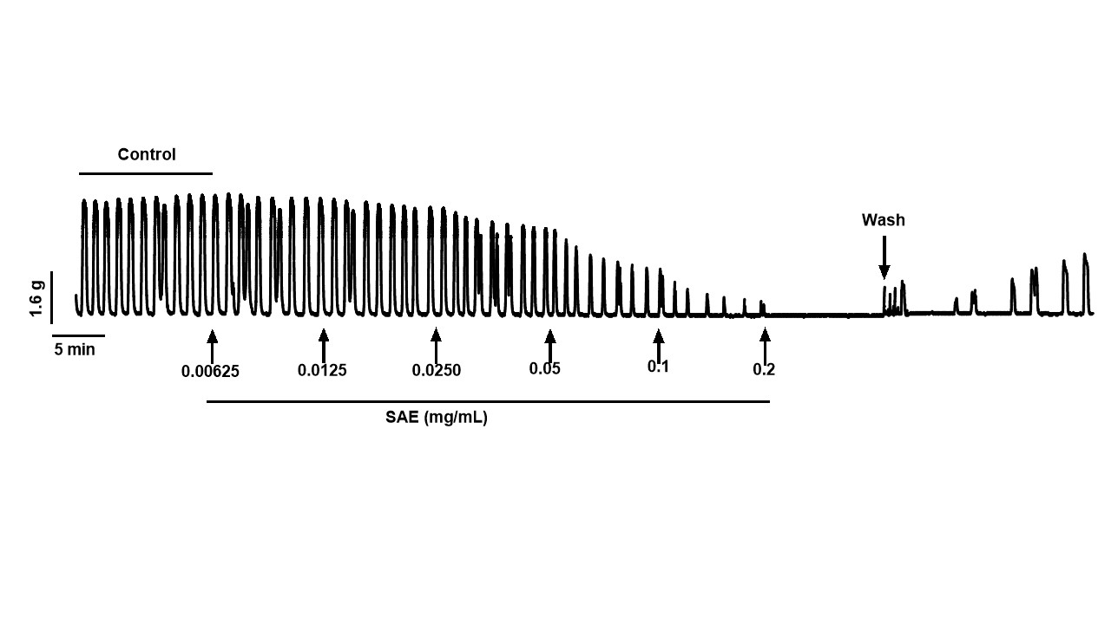
Figure 3.1 Effect of the hydroalcoholic extract of S. aromaticum (SAE) on spontaneous uterine contractility of non-pregnant animals.
Original representative recording showing the effect of SAE on spontaneous uterine contractility in non pregnant mice

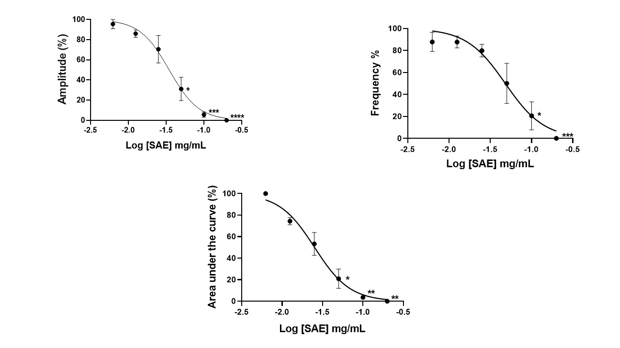

Figure 3.2 Effect of the hydroalcoholic extract of S. Aromaticum (SAE) on (A) amplitude (B) frequency and (C) area under the curve of spontaneous uterine contractility of non-pregnant uterus. Values are mean ± SEM, *p<0.05, **p<0.01, ***p<0.0001, p<0.00001 n = 5 animals.

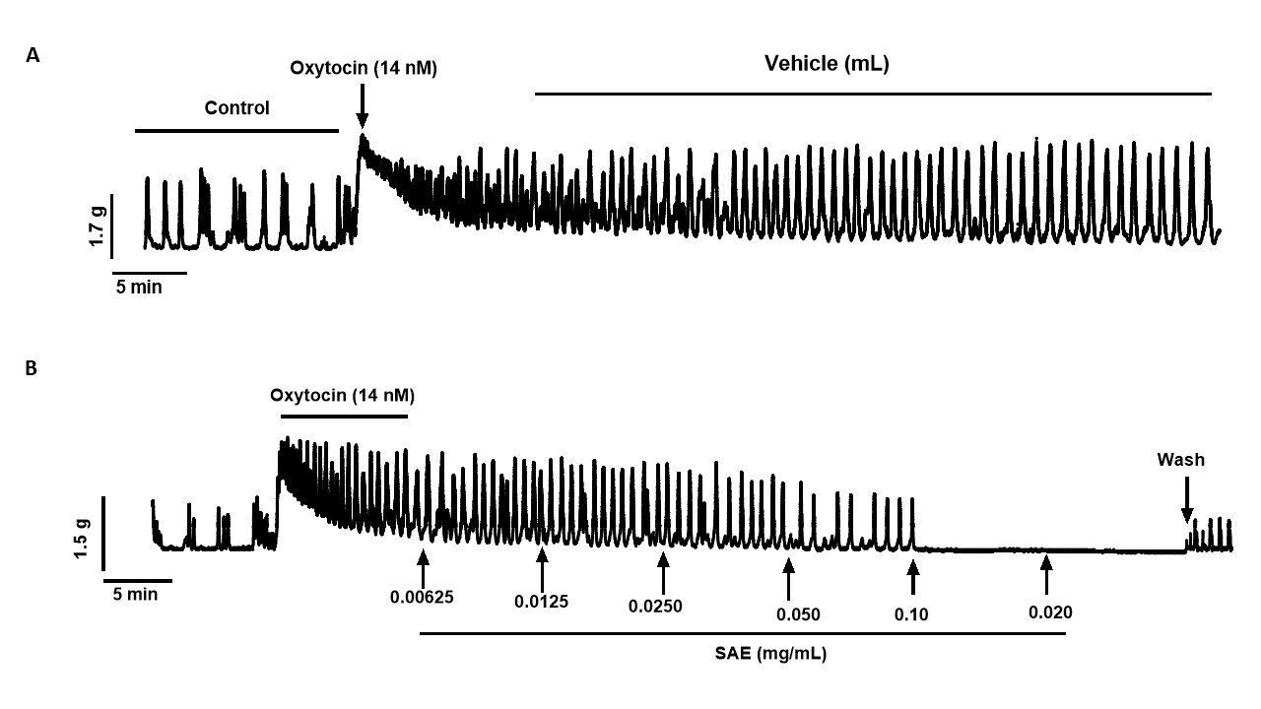

Figure 3.3. Effect of the hydroalcoholic extract of S. aromaticum (SAE) on oxytocin-induced uterine contractions in non-pregnant animals.
Original representative recordings showing (A) the effect of oxytocin on non-pregnant uterine contractions as control; (B) Effect of SAE oxytocin-induced contractions of the non-pregnant mouse uterus.

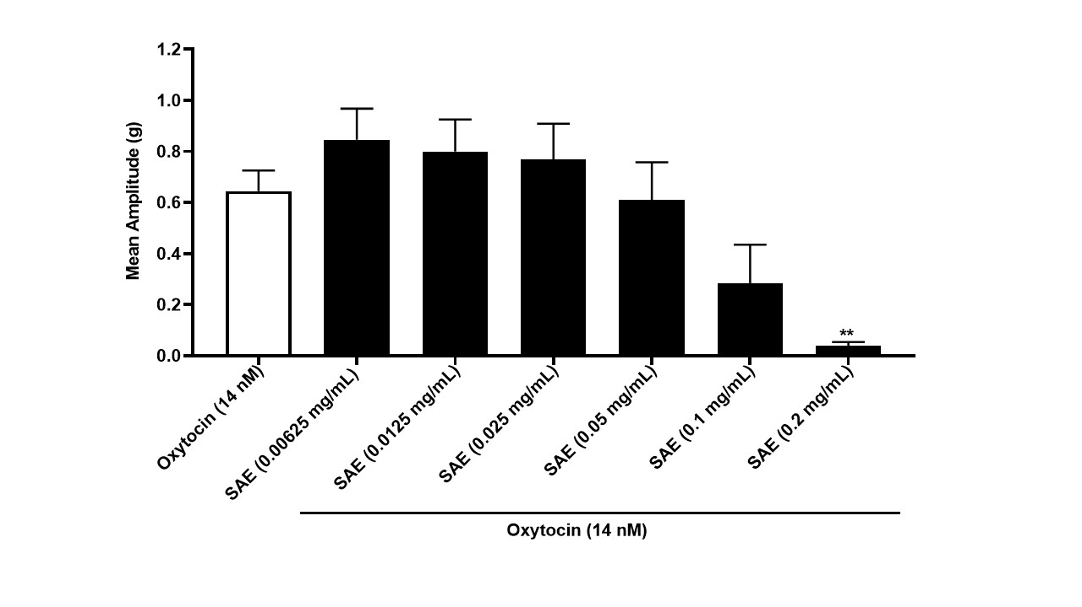
B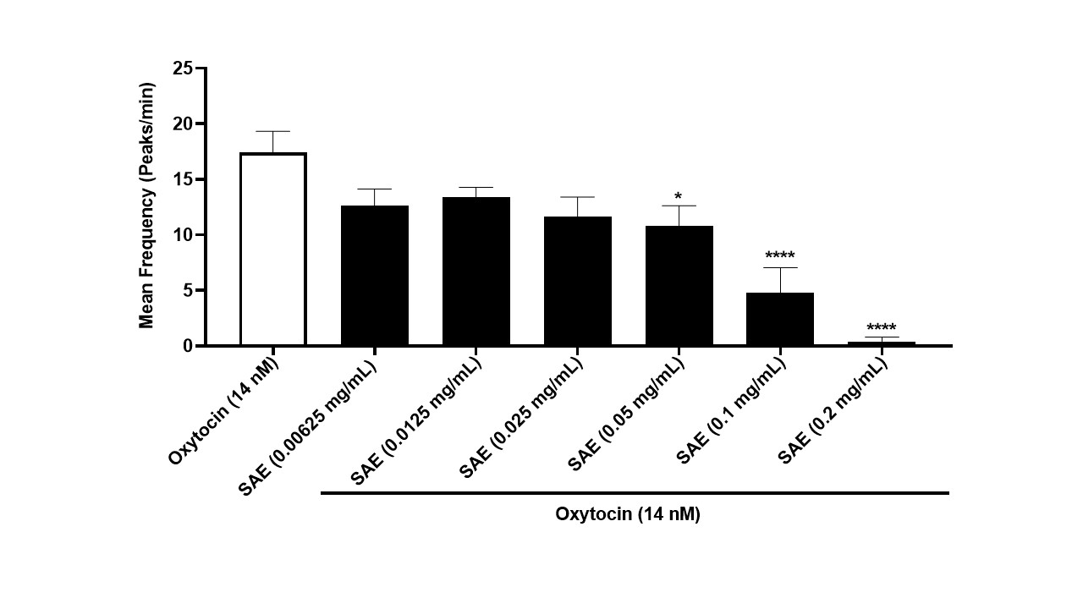
A
B
Figure 3.4. Effect of the hydroalcoholic extract of S. aromaticum (SAE) on oxytocin (OT) induced uterine contractions in non-pregnant animals.
(A) SAE inhibited the amplitude of OT (*P<0.01) (B) SAE gradually inhibited the frequency of OT (*p<005, ****p<0.00001). Values are mean ±SEM, n=5 animals
3.3 Effect of Hydralcoholic Extract of S. aromaticum on High KCl-Induced Non-Pregnant Uterine Contractions
Figure 3.5 (A) shows sustained contractions caused by the addition of high KCl. It also shows that there was no effect of the vehicle on its contraction. The effect of SAE on KCl-induced contractions is shown in Figure 3.5 (B). High KCl produced a rapid and sustained increase in force of contraction (Figure 3.5). The introduction of SAE in the presence of KCl (80mM) significantly diminished the high KCl-induced contraction on non-pregnant mice uterine tissues (Figure 3.5), compared to KCl alone. In the presence of SAE, there was no significant inhibition of amplitude.

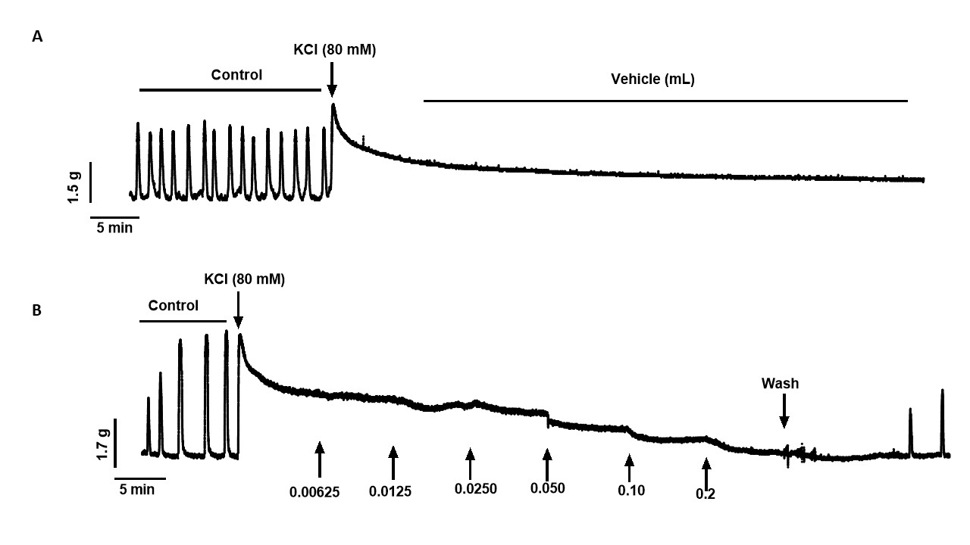

Figure 3.5. Effect of the hydroalcoholic extract of S. aromaticum (SAE) on high KCl-induced uterine contractions in non-pregnant animals.
Original representative recordings showing (A) the effect of high Kcl on non-pregnant uterine contractions as control; (B) Effect of SAE on n-induced contractions of the non-pregnant mouse uterus.

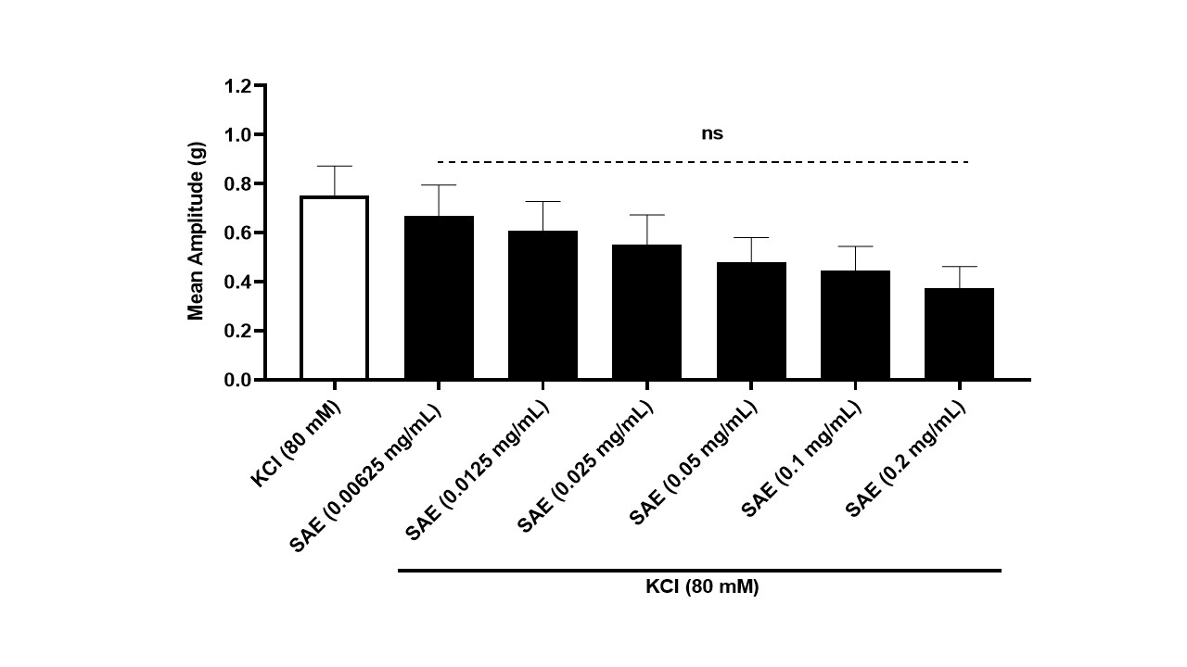

Figure 3.6. The effect of the hydroalcoholic extract of S. aromaticum (SAE) on amplitude of high KCl-induced uterine contractions in non-pregnant animals.
Values are mean ± SEM, n = 5 animals

CHAPTER 4
DISCUSSION
Herbal medicines have played a significant role in traditional health care across different cultures for thousands of years. For thousands of years, herbal remedies have been an important part of traditional medical care in many cultures. Phytochemicals are a broad class of biologically active substances found in plants that frequently have therapeutic qualities. S. aromaticum, or clove, is one such plant that has long been utilized for its analgesic, anti-inflammatory, antibacterial, and muscle-relaxant properties. Eugenol, a phenolic molecule with calcium channel blocking, antioxidant, and smooth muscle relaxant qualities, is the primary active ingredient in clove. These attributes make clove a promising candidate for studies investigating its possible tocolytic potential.
The study investigated the potential tocolytic effects of S. aromaticum (SAE) extract, commonly known as clove, on myometrial contractility using an isolated non-pregnant mouse uterine model. The research also aimed to compare the effect of the extract on different types of induced contractions, including oxytocin-induced and potassium chloride induced contractions. Tocolysis plays a critical role in the clinical management of preterm labor, defined as regular uterine contractions accompanied by cervical changes before 37 weeks of gestation. Contributing to consequences like respiratory distress syndrome, intraventricular hemorrhage, necrotizing enterocolitis, and long-term neurodevelopmental damage, this disorder continues to be a major global cause of newborn morbidity and mortality. In order to enable evidence-based therapies that improve fetal outcomes, the main therapeutic goal of tocolysis is to reduce myometrial activity for a brief, clinically significant period of time, usually 24 to 72 hours, rather than to achieve term gestation. Biochemical, hormonal, and electrophysiological signals interact intricately to control the highly coordinated physiological process of uterine contractility.
In spontaneous contractions, the extract progressively reduced both the amplitude and frequency of contractions. This indicates that the extract has a direct relaxant effect on the uterine smooth muscle even without any external stimulation. The reversibility of contractions after washout of the extract confirms that the effect is not due to tissue damage but rather to a pharmacological action potentially through modulation of calcium homeostasis or cyclic nucleotide pathways, akin to the mechanisms of established tocolytics.
Uterine spontaneous contractions refer to rhythmic, coordinated contractions of the myometrial smooth muscle that occur even in the absence of external stimulation. This activity originates from the cyclic depolarization and repolarization of the myometrial membrane, leading to the generation of action potentials. When the membrane potential depolarizes beyond a certain threshold, voltage-gated calcium channels, particularly the L-type calcium channels, open to allow calcium influx from the extracellular space into the cytoplasm (Wray et al., 2003). The increase in intracellular calcium concentration serves as a primary trigger for uterine contractions. Once inside the cell, calcium ions bind to calmodulin to form a calcium–calmodulin complex, which activates myosin light chain kinase (MLCK). This enzyme phosphorylates the myosin light chains, enabling interaction with actin filaments and resulting in cross-bridge cycling and force generation (Word et al., 1993). Besides extracellular calcium influx, intracellular calcium release from the sarcoplasmic reticulum via inositol trisphosphate receptors (IP₃Rs) and ryanodine receptors (RyRs) further amplifies cytosolic calcium levels, sustaining contractility (Arrowsmith et al., 2014).
Hormonal modulation is another critical aspect of spontaneous uterine contractility. Estrogen increases myometrial excitability by enhancing calcium channel expression and gap junction formation, while progesterone exerts a relaxing influence by promoting membrane hyperpolarization and reducing calcium entry (Wray et al., 2001). Thus, the balance between estrogen and progesterone plays a vital role in determining whether the uterus remains quiescent or becomes contractile. Ion channels also contribute significantly to the regulation of uterine activity. In addition to L-type calcium channels, potassium (K⁺) and chloride (Cl⁻) channels influence the resting membrane potential. Activation of calcium-activated potassium channels (BKCa) promotes hyperpolarization and relaxation, whereas inhibition of these channels enhances depolarization and excitability (Tribe et al., 2000).
In addition to ion channels, endogenous agents such as prostaglandins and oxytocin play vital roles in modulating spontaneous uterine contractions. Prostaglandins, especially PGF₂α and PGE₂, as well as oxytocin, enhance contractility by increasing intracellular calcium levels through the activation of the phospholipase C (PLC)–inositol trisphosphate (IP₃) pathway (Arrowsmith & Wray, 2014). Binding of oxytocin to its receptor activates Gq proteins, leading to IP₃-mediated calcium release from intracellular stores, thereby intensifying myometrial contractions.
This results of my findings is consistent with the phytochemistry of clove buds earlier described where the main bioactive component found to be eugenol (70–85% of essential oil) inhibiting voltage-gated calcium channels and lowering intracellular calcium levels (both necessary for actin-myosin cross-bridging in smooth muscle contraction) are two of eugenol's well-known calcium channel antagonistic characteristics (Ali et al., 2015; Hazim et al., 2023). As demonstrated by chamomile and ginger, other components like β-caryophyllene and eugenyl acetate may contribute through nitric oxide-mediated relaxation or anti-inflammatory pathways (Srivastava et al., 2010). SAE's safety profile in conventional medicine is supported by the reversible nature of the inhibition during washing, which suggests it does not harm myometrial tissue irreversibly (Bent, 2008). The AUC reduction quantifies the overall inhibitory potency, suggesting SAE could provide a therapeutic window aimed for use in clinical tocolysis.
In oxytocin-induced contractions, the extract caused a marked and progressive inhibition of both the strength and frequency of contractions.
Oxytocin acts by binding to specific oxytocin receptors (OTRs) located on the plasma membrane of uterine smooth muscle cells. These receptors are G protein-coupled receptors (GPCRs), primarily associated with the Gq/11 protein family. Upon ligand binding, the receptor undergoes conformational activation that stimulates phospholipase C (PLC-β) activity. Activated PLC catalyzes the hydrolysis of membrane-bound phosphatidylinositol 4,5-bisphosphate (PIP₂) into two second messengers: inositol 1,4,5-trisphosphate (IP₃) and diacylglycerol (DAG) (Arrowsmith & Wray, 2014). IP₃ diffuses through the cytosol and binds to IP₃ receptors on the sarcoplasmic reticulum (SR), leading to the release of calcium ions (Ca²⁺) into the cytoplasm. This transient increase in intracellular Ca²⁺ concentration is a critical step in initiating uterine contraction.
The rise in intracellular calcium triggers a cascade of molecular events leading to myometrial contraction. Calcium binds to calmodulin, forming a calcium–calmodulin complex that activates myosin light chain kinase (MLCK). Activated MLCK phosphorylates the regulatory light chains of myosin, which allows myosin heads to interact with actin filaments, forming cross-bridges that generate contractile force (Word et al., 1993). In addition to the release of intracellular calcium, oxytocin also facilitates extracellular calcium influx through voltage-gated L-type calcium channels (VGCCs), further sustaining elevated cytosolic calcium levels necessary for continued contraction (Wray et al., 2003).
Meanwhile, the DAG produced alongside IP₃ activates protein kinase C (PKC), which modulates the activity of several calcium-handling proteins and contributes to the sensitization of the contractile machinery. PKC, together with the RhoA/Rho kinase (ROCK) pathway, plays a vital role in increasing calcium sensitivity of the myofilaments. Activation of RhoA leads to the stimulation of Rho kinase, which in turn inhibits myosin light chain phosphatase (MLCP), the enzyme responsible for dephosphorylating myosin light chains. This inhibition maintains myosin in its phosphorylated, contractile state even without further increases in calcium concentration, thereby enhancing and prolonging uterine contractions (Khalil, 2010; Wray et al., 2014).
Since oxytocin increases uterine contraction by elevating intracellular calcium levels, the inhibition observed suggests that the extract may either block oxytocin receptors or interfere with the signaling pathway that leads to calcium release. This finding agrees with previous studies that reported eugenol and related phenolic compounds as inhibitors of oxytocin-induced uterine contractions through calcium channel blockade. Given eugenol's documented affinity for G-protein-coupled receptors, SAE's effect may include competitive antagonism or modification of vasopressin V1a receptors (Batiha El-Saber et al., 2020). As an alternative, the extract's phenolic components (such as derivatives of gallic acid) may prevent phospholipase C from activating, which would lessen IP3-mediated calcium release from the sarcoplasmic reticulum. Research on related plants, such as fennel (Foeniculum vulgare), which has spasmolytic effects through calcium antagonism and estrogenic regulation, supports this (Akdogan et al., 2004).
In high Kcl induced contractions, the extract showed no significant inhibition in the amplitude of contractions. High KCl induces tonic contractions by depolarizing the myometrial membrane, opening voltage-gated calcium channels, and causing sustained calcium influx.
When the extracellular concentration of potassium ions is markedly increased, the electrochemical gradient across the myometrial cell membrane is altered. Normally, potassium ions maintain the resting membrane potential around 50 to −60 mV through continuous efflux via potassium channels. However, the addition of high concentrations of KCl reduces the potassium gradient and causes membrane depolarization. This depolarization activates L-type voltage-gated calcium channels (CaV1.2) on the sarcolemma, leading to a sustained influx of extracellular calcium ions into the cytoplasm (Tribe et al., 2000). The resulting rise in intracellular Ca²⁺ concentration serves as the primary trigger for uterine smooth muscle contraction.
Once inside the cytoplasm, the calcium ions bind to calmodulin, a calcium-binding protein, forming a Ca²⁺–calmodulin complex that activates myosin light chain kinase (MLCK). The activated MLCK phosphorylates the regulatory light chains of myosin heads, allowing them to bind to actin filaments and initiate cross-bridge cycling, resulting in contraction of the myometrial cells (Word et al., 1993). Unlike receptor-mediated pathways that involve secondary messengers such as inositol trisphosphate (IP₃) or diacylglycerol (DAG), KCl-induced contractions are predominantly dependent on direct calcium influx from the extracellular medium rather than release from intracellular stores. This explains why the removal of extracellular calcium or blockade of L-type calcium channels using agents such as nifedipine effectively abolishes KCl-induced contractions (Wray, 2014; Shmygol et al., 2007).
In addition to triggering calcium influx, high KCl depolarization can also activate voltage-dependent sodium and chloride channels, contributing to the stabilization of the depolarized state and sustaining calcium entry. The elevated intracellular calcium not only activates MLCK but also stimulates the RhoA/Rho kinase (ROCK) signaling pathway, which increases the calcium sensitivity of the contractile apparatus. Rho kinase achieves this by inhibiting myosin light chain phosphatase (MLCP), the enzyme responsible for dephosphorylating myosin light chains, thereby maintaining myosin in a phosphorylated, contractile state (Khalil, 2010). The involvement of the RhoA/ROCK pathway ensures that contractions persist even when intracellular calcium levels begin to decline slightly, resulting in a sustained tonic contraction typical of high KCl stimulation.
From the results observed, the extract’s inability to affect KCl induced contractions suggests that SAE does not interfere with extracellular calcium influx.

CHAPTER 5
CONCLUSION
The results of this investigation unequivocally show that S. aromaticum extract has strong uterine relaxing properties. The mechanism of action is probably associated with modification of intracellular calcium storage, interference with oxytocin receptor-mediated calcium release, or suppression of calcium influx through voltage-gated calcium channels. These results strongly imply that S. aromaticum may be a natural source of bioactive substances with tocolytic qualities, providing a safer substitute for traditional medications used to treat premature labor.
However, further studies are needed to fully elucidate the molecular mechanisms underlying its effects and to assess its safety and efficacy in clinical settings. This study lays a promising foundation for the development of SAE based treatments aimed at improving uterine health.
5.1 Recommendations
Further studies are needed to fully elucidate the molecular mechanisms underlying its effects and to assess its safety and efficacy in clinical settings. This study lays a promising foundation for the development of SAE-based treatments aimed at improving uterine health.

REFERENCES
Abd El-Baky, H.H. & El-Baroty, G.S. (2013). Characterization of bioactive compounds from clove (Syzygium aromaticum L.). African Journal of Pharmacy and Pharmacology, 7(14), 763–770.
Adefolaju, T. & Bafor, E.E. (2018). Modulation of uterine contractility by herbal extracts: a review. Journal of Ethnopharmacology, 219, 297–309.
Adeyemi, O.O., et al. (2018). Effects of plant-derived compounds on uterine smooth muscle. African Journal of Reproductive Health, 22(4), 98–107.
Akdogan, M., Ozguner, M. & Aydin, G. (2004). Effects of peppermint (Mentha piperita) on smooth muscle relaxation. Phytotherapy Research, 18(8), 623–626.
Ali, B., Al-Wabel, N.A., Shams, S. & Ahamad, A. (2015). Essential oils used as tocolytic agents: pharmacological basis and clinical potential. Phytomedicine, 22(7–8), 631–638.
Almeida, R.N. (2017). Phytochemicals and smooth muscle pharmacology. Brazilian Journal of Pharmacognosy, 27(1), 17–28.
Aremu, A.O. & Moyo, M. (2019). Antioxidant and antimicrobial activities of Syzygium aromaticum: A review. Food Chemistry, 276, 475–485.
Awang, D.V.C. (2002). Ginger (Zingiber officinale): A review of its medicinal properties. HerbalGram, 56, 1–14.
Bafor, E.E. & Emiloju, O.C. (2019). Evaluation of uterine relaxant activity of plant extracts using organ bath studies. African Journal of Biomedical Research, 22(1), 33–40.
Bafor, E.E., Omoruyi, S.I. & Ighodaro, O.M. (2020). Effects of medicinal plant extracts on isolated uterine tissue. Journal of Reproductive Pharmacology, 8(2), 121–129.
Batiha, G.E., Beshbishy, A.M., Wasef, L.G. et al. (2020). Chemical composition and biological activities of clove essential oil. Molecules, 25(21), 1–19.
Batiha, G.E.-S., Wasef, L.A., Beshbishy, A.M., El-Hack, M.E.A., Taha, A.E., Al-Sagan, A.A., et al., 2020. Phytochemistry, pharmacology, and therapeutic potential of clove (Syzygium aromaticum): A comprehensive review. Biomolecules, 10(11), p.1476.
Bent, S. (2008). Herbal medicine in the United States: Review of efficacy, safety, and regulation. JAMA, 299(13), 1567–1576.
Bhowmik, D., et al. (2012). Medicinal uses of clove: An overview. Journal of Natural Remedies, 12(2), 90–97.
Boehm, C.R. & Blackwell, C. (2020). Calcium signaling and uterine contractility. Reproductive Sciences, 27(5), 1141–1154.
Bulletti, C., De Ziegler, D., Polli, V. & Flamigni, C. (2000) Uterine contractility during the menstrual cycle. Human Reproduction, 15(suppl_1), pp. 81-89.
Bulletti, C., De Ziegler, D., Polli, V., O'Connor, A.M. & Flamigni, C. (2008) The electromechanical activities of human uteri during extra-corporeal perfusion with ovarian steroids. Human Reproduction, 8(7), pp. 1109-1113.
Burbach, J.P.H., Young, L.J. & Russell, J.A. (2006) Oxytocin synthesis, secretion and reproduction. In: Knobil and Neill’s Physiology of Reproduction. 3rd edn. Elsevier, pp. 3055-3128.
Byers, S.L., Wiles, M.V., Dunn, S.L. and Taft, R.A., 2012. Mouse estrous cycle identification tool and its impact on reproducibility of research. Biology of Reproduction, 87(6), p.151.
Calixto, J.B. (2019). The role of natural products in modern drug discovery. Brazilian Journal of Medical and Biological Research, 52(3), 1–11
Chan, K. (2015). Quality control of herbal medicines. Journal of Ethnopharmacology, 140(3), 451–458.
Cora, M.C., Kooistra, L. and Travlos, G., 2015. Vaginal cytology of the laboratory rat and mouse: Review and criteria for the staging of the estrous cycle. Toxicologic Pathology, 43(6), pp.776–793
Crowther, C.A., Hiller, J.E., Doyle, L.W. and Haslam, R.R., 2002. Betamimetics for inhibiting preterm labour. Cochrane Database of Systematic Reviews, (1), CD004352.
Cunha, G.R., 2004. The human and mouse urogenital tracts: Developmental perspectives and applications. International Journal of Developmental Biology, 48(2-3), pp.165–177.
Di Renzo, G.C., Cabero Roura, L., Facchinetti, F., Helmer, H., Hubinont, C., Jacobsson, B., Jørgensen, J.S., Lamont, R.F., Mikhailov, A., Papantoniou, N., Radzinsky, V., Shennan, A., Ville, Y., Wielgos, M. & Visser, G.H.A. (2017) Preterm Labor and Birth Management: Recommendations from the European Association of Perinatal Medicine. Journal of Maternal-Fetal & Neonatal Medicine, 30(17), pp. 2011-2030.
Dlamini, N., Ekor, M. & Oladipupo, F. (2017). Safety of herbal medicines: Regulatory perspectives. African Journal of Traditional, Complementary and Alternative Medicines, 14(2), 91–103.
Dodd, J.M., Crowther, C.A., Haslam, R.R. and Hiller, J.E., 2003. Maternal and neonatal effects of tocolytics in preterm labor: Systematic review. BJOG, 110(10), pp.947–955.
Ekor, M. (2014). The growing use of herbal medicines: Issues relating to adverse reactions and challenges in monitoring safety. Frontiers in Pharmacology, 4, 177.
Fabricant, D.S. & Farnsworth, N.R. (2001). The value of plants used in traditional medicine for drug discovery. Environmental Health Perspectives, 109(Suppl 1), 69–75.
Fakeye, T.O. (2014). Herbal medicine use in obstetrics: An evidence-based review. Phytomedicine, 21(8–9), 997–1011.
Farnsworth, N.R., Akerele, O., Bingel, A.S., Soejarto, D.D. & Guo, Z. (1985) Medicinal plants in therapy. Bulletin of the World Health Organization, 63(6), pp. 965-81.
Fischer, R., Dudenhausen, J.W. and Berg, C., 2001. Atosiban for the management of preterm labor: Efficacy and safety review. Drugs, 61(12), pp.1801–1822.
Fleischer, A.C., Kalemeris, G.C., Machin, J.E., Entman, S.S. & James, A.E. (1986) Sonographic depiction of normal and abnormal endometrium with histopathologic correlation. Journal of Ultrasound Medicine, 5(8), pp. 445-52.
Fraser, I.S. & Lethaby, A. (2018). Regulation of uterine contractility: physiology and pharmacology. Best Practice & Research Clinical Obstetrics and Gynaecology, 50, 68–82.
Friedman, M. & Kozukue, N. (2021). Natural compounds as calcium antagonists. Food Chemistry, 347, 129002.
Ganong, W.F., 2019. Review of Medical Physiology. 26th ed. New York: McGraw-Hill Education.
Gimpl, G. & Fahrenholz, F. (2001) The oxytocin receptor system: structure, function, and regulation. Physiological Reviews, 81, pp. 629-683.
Gupta, A.K. & Misra, N. (2018). Herbal approaches to uterine disorders. Indian Journal of Pharmacology, 50(5), 237–246.
Gurib-Fakim, A. (2006) Medicinal plants: Traditions of yesterday and drugs of tomorrow. Molecular Aspects of Medicine, 27(1), pp. 1–93.
Guyton, A. C. & Hall, J. E. (2023). Textbook of Medical Physiology (14th ed.). Elsevier.
Halberstein, R.A. & Saunders, E.L. (1978) Traditional medical practices and medicinal plants of the Indians of Mishik, Ecuador. Social Science & Medicine, 12(5), pp. 22-3
Hanley, M., Sayres, L., Reiff, E.S., Wood, A., Grotegut, C.A. & Kuller, J.A. (2019) Tocolysis: A Review of the Literature. Obstetrical & Gynecological Survey, 74(1), pp. 50-55.
Haas, D.M., Caldwell, D.M., Kirkpatrick, P., McIntosh, J. and Welton, N.J., 2012. Tocolytic therapy for preterm delivery: Systematic review and network meta-analysis. BMJ, 345:e6226.
Hassauer, W. & Graeff, H. (1985) Fruehgeburtsprophylaxe im Rahmen des Muetterpasses. Zeitschrift fur Geburtshilfe und Perinatologie, 189(3), pp. 144–50.
Hazim, H., Ozturk, M., Sari, F., Uslu, B., Koksal, E., Yilmaz, M., et al., 2023. Chemical composition and pharmacological potential of clove essential oil (Syzygium aromaticum). Journal of Essential Oil Research, 35(4), pp.342–358..
Heuser, C.C., Knight, S., Esplin, M.S., Eller, A.G., Holmgren, C.M., Manuck, T.A., Richards, D., Henry, E. & Jackson, G.M. (2013) Tachysystole in term labor: incidence, risk factors, outcomes, and effect on fetal heart tracings. American Journal of Obstetrics and Gynecology, 209(1), pp. 32.e1-6.
Heinrich, M. & Jäger, A. (2015). Ethnopharmacology. London: Wiley-Blackwell.
Hoffman, B. & Schorge, J. (2018). Williams Gynecology, 4th ed. New York: McGraw-Hill.
Ijland, M.M., Evers, J.L.H., Dunselman, G.A.J., Van Katwijk, C. & Hoogland, H.J. (1996) Endometrial wave characteristics in the non-pregnant uterus. Human Reproduction Update, 2(3), pp. 209-218.
Izzo, A.A. & Ernst, E. (2009). Interactions between herbal medicines and prescribed drugs. Drugs, 69(13), 1777–1798.
Khandelwal, K.R. (2016). Practical Pharmacognosy. Pune: Nirali Prakashan.
Khan, A., Bashir, S. & Sultana, R. (2019). Medicinal plants as potential tocolytics: A review. Phytotherapy Research, 33(3), 482–496.
Kumar, V. et al. (2019). Phytochemical screening of clove and evaluation of pharmacological activities. Journal of Applied Pharmaceutical Science, 9(3), 43–49.
Lal, S. & Singh, R. (2020). Role of oxidative stress in preterm labor. Reproductive Biology and Endocrinology, 18(1), 1–12.
Lee, J.H., Kim, H., Koo, J., Kim, H. and Lim, H., 2010. Morphological and histological characteristics of the mouse uterus. Laboratory Animals Research, 26(2), pp.67–73.
Marieb, E.N., Hoehn, K. and Mallatt, J., 2021. Human Anatomy & Physiology. 11th ed. Boston: Pearson.
Mercer, B.M., 2014. Preterm labor: Tocolytic therapy and outcomes. Obstetrics & Gynecology, 123(3), pp.531–540.
Mirabzadeh, M., Zolghadri, J. & Faghihi, M. (2013). Uterine relaxant effects of licorice (Glycyrrhiza glabra) extract. Iranian Journal of Reproductive Medicine, 11(6), 503–510.
Murray, R.K., Bender, D.A. & Botham, K.M. (2020). Harper’s Illustrated Biochemistry. 32nd ed. New York: McGraw-Hill.
Nahas, R. & Moher, M. (2011). Complementary therapies for pregnancy-related symptoms. Canadian Family Physician, 57(6), 659–663.
National Research Council (2010). Guide for the Care and Use of Laboratory Animals, 8th ed. Washington, DC: National Academies Press.
Norman, J.E., Marlow, N., Messow, C.M., Shennan, A.H., Bennett, P.R., 2010. Tocolytic agents for preterm labor: Maternal and neonatal outcomes. American Journal of Obstetrics & Gynecology, 203(2), pp.130.e1–130.e7.
Ogunlana, O.O. & Adebayo, O.J. (2019). Ethnopharmacological relevance of Syzygium aromaticum. International Journal of Pharmacognosy and Phytochemical Research, 11(3), 118–125.
Okoro, O.E. & Bafor, E.E. (2022). Evaluation of uterine contractility using plant extracts. Journal of Applied Physiology and Pharmacology, 5(1), 55–63.
Onyeka, C. et al. (2023). Comparative effects of herbal tocolytics in mice. Nigerian Journal of Pharmaceutical Research, 19(2), 112–121.
Parkening, T.A., Collins, T.J. & Smith, E.R. (1982). Estrous cycle and reproductive physiology in mice. Biology of Reproduction, 27(4), 885–891.
Parkington, H.C., Coleman, H.A. and Brading, A.F., 2010. Electrophysiology of the myometrium. In: Uterine Function and Dysfunction. Springer, pp.55–78.
Patil, U. & Pande, V. (2021). A review on calcium channel blockers from plant origin. Phytochemistry Reviews, 20(2), 231–247.
Patwardhan, B., Vaidya, A.D.B. & Chorghade, M. (2015). Ayurveda and natural products drug discovery. Current Science, 89(3), 289–298.
Plant, T.M., Zeleznik, A.J. and Knobil, E., 2016. The Neuroendocrine Control of the Menstrual Cycle. 2nd ed. San Diego: Academic Press
Rates, S.M.K. (2001). Plants as a source of drugs. Toxicon, 39(5), 603–613.
Romero, R., Nicolaides, K., Conde-Agudelo, A., et al., 2000. Oxytocin receptor antagonists for preterm labor. American Journal of Obstetrics & Gynecology, 183(4), pp.1011–1019.
Sadler, T.W., 2018. Langman’s Medical Embryology. 14th ed. Philadelphia: Wolters Kluwer.
Shynlova, O., Nedd-Roderique, T., Li, Y. and Lye, S.J., 2009. Myometrial contraction and regulation in pregnancy and labor. Reproductive Sciences, 16(1), pp.15–27.
Smith, V., Crowther, C.A., Dodd, J.M., et al., 2010. Tocolysis in preterm labor: Comparative review of beta-agonists and oxytocin antagonists. BJOG, 117(7), pp.720–730.
Sofowora, A. (2008). Medicinal Plants and Traditional Medicine in Africa. Ibadan: Spectrum Books Ltd.
Srivastava, J.K., Shankar, E. & Gupta, S. (2010). Chamomile: A herbal medicine of the past with bright future. Molecular Medicine Reports, 3(6), 895–901.
Tilburt, J.C. & Kaptchuk, T.J. (2008). Herbal medicine research and global health. World Health Organization Bulletin, 86(8), 594–599.
Thaler, I., Schindler, M., Ulrich, D., et al., 2010. Pharmacology of calcium channel blockers in obstetric practice. Current Pharmaceutical Design, 16(27), pp.3065–3077.
Tripathi, K.D. (2019). Essentials of Medical Pharmacology. 8th ed. New Delhi: Jaypee Brothers.
Uche, F.I. & Bafor, E.E. (2023). Pharmacological screening of natural tocolytics. African Journal of Reproductive Sciences, 13(1),
Uchendu, C.N. & Bafor, E.E. (2023). Mechanisms of uterine relaxation by natural products in mice. Journal of Reproductive Pharmacology, 9(2), 112–121.
Van Gestel, I., Van Engeland, M., Arts, M.J.P. & Helmerhorst, F.M. (2003) Endometrial wave-like activity in the non-pregnant uterus. Human Reproduction Update, 9(2), pp. 131-138.
Vane, J.R. (1971) Inhibition of prostaglandin synthesis as a mechanism of action for aspirin-like drugs. Nature New Biology, 231(25), pp. 232-5.
Walmer, D.K., Wrona, M.A. & Hughes, C.L. (1992). Estrous cycle-dependent changes in the mouse uterus. Biology of Reproduction, 46(4), 508–515.
Wray, S., Jones, K.M., Kupittayanant, S., Li, Y., Matthew, A., Monir-Bishty, E., ... & Shmygol, A. (2003) Calcium signaling and uterine contractility. Journal of the Society for Gynecologic Investigation, 10(4), pp. 200-214
Wray, S. (2007) Uterine contraction and the role of calcium. Journal of the Society for Gynecologic Investigation, 14(7), pp. 416-423..
Wray, S., Arrowsmith, S. and Shynlova, O., 2015. Uterine contraction and myometrial physiology. In: Physiology of Reproduction. 3rd ed. Elsevier, pp.1135–1167.
Wray, S. & Prendergast, C. (2019) The Myometrium: From Excitation to Contractions and Labour. Advances in Experimental Medicine and Biology, 1124, pp. 233-263.
WHO (2013). WHO Traditional Medicine Strategy 2014–2023. Geneva: World Health Organization.

